Walking Both Sides by Cheryl Rainfield, mini book 1:12 scale.
CherylPainfield.com/cheryl-rainfields-miniature-books/ Free for personal use only.
Print. Cut cover and paste onto thin cardstock. Cut pages in one long horizontal strip, pages still connected. Accordion fold along lines of pages. Glue white backs of pages together. Glue along spine, insert into cover. Clamp with binder clamp until dry.

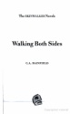 |  | 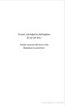 | 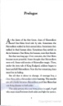 | 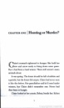 | 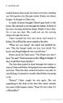 |  | 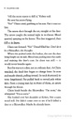 | 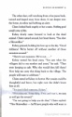 | 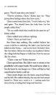 | 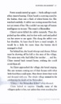 | 