School Books & Sorcery anthology, short story by Cheryl Rainfield, mini book 1:12 scale.
CherylPainfield.com/cheryl-rainfields-miniature-books/ Free for personal use only.
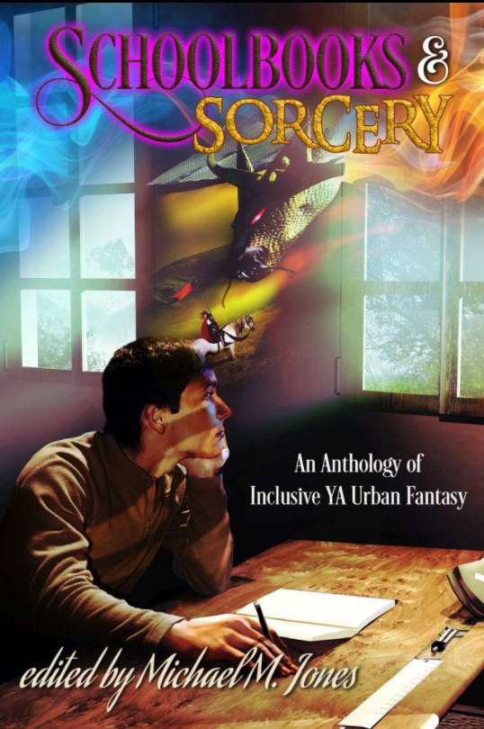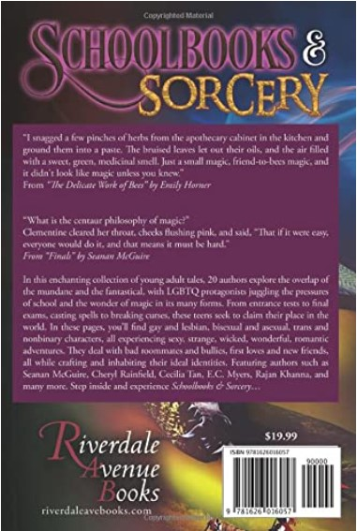
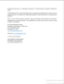 | 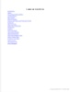 | 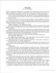 | 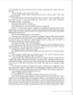 | 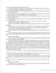 | 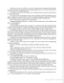 | 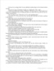 | 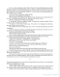 | 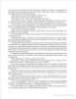 | 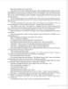 | 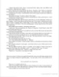 | 